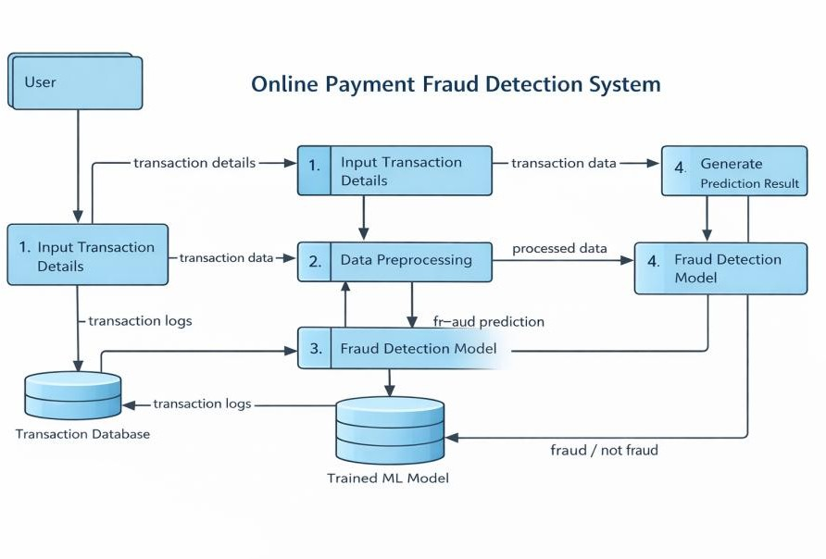
Project Design Phase-II

Data Flow Diagram & User Stories

Date | 18 February 2026
Team ID | LTVIP2026TMIDS65699
Project Name | Online Payments Fraud Detection using Machine Learning
Maximum Marks | 4 Marks

Data Flow Diagrams:
A Data Flow Diagram (DFD) is a traditional visual representation of the information flows within a system. A neat and clear DFD can depict the right amount of the system requirement graphically. It shows how data enters and leaves the system, what changes the information, and where data is stored.
Example: DFD Level 0 (Industry Standard)

Example: (Simplified)
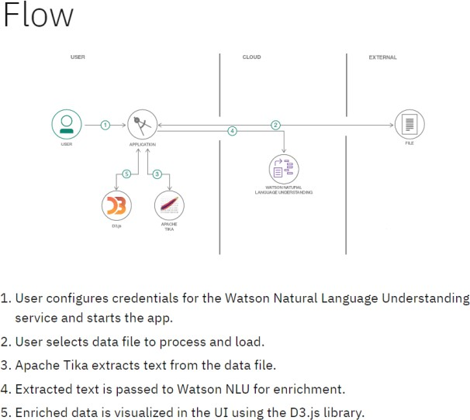

User Stories
Use the below template to list all the user stories for the product.

User Type | Functional Requirement (Epic) | User Story Number | User Story / Task | Acceptance criteria | Priority | Release
Customer (Web user) | Registration | USN-1 | As a user, I can access the fraud detection system | User can open the  application page successfully. | High | Sprint-1
Customer | Transaction Input | USN-2 | As a user, I can select transaction type (CASH_IN, PAYMENT, TRANSFER, etc.) | Dropdown displays all transaction types correctly. | High | Sprint-1
Customer | Fraud Detection | USN-3 | As a user, I can click “Detect Fraud” to  analyze my transaction | System processes input without error | High | Sprint-1
Customer | View Result | USN-4 | As a user, I can see whether the transaction is Fraud or Legitimate. | System displays clear fraud / safe result. | High | Sprint-1
Admin | Model Training | USN-5 | As an admin, I can train and update the ML model | Model accuracy improves and updates properly | Medium | Sprint-2
Admin | Data Storage | USN-6 | As an admin, I can store transaction logs for analysis | All transactions are saved in database | Medium | Sprint-2

